Case study on



Athena

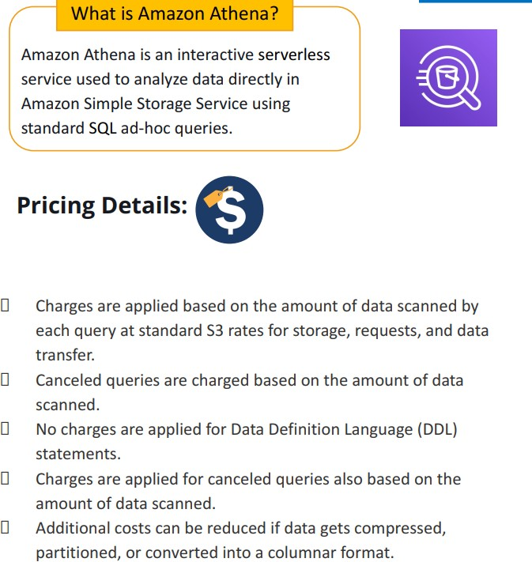

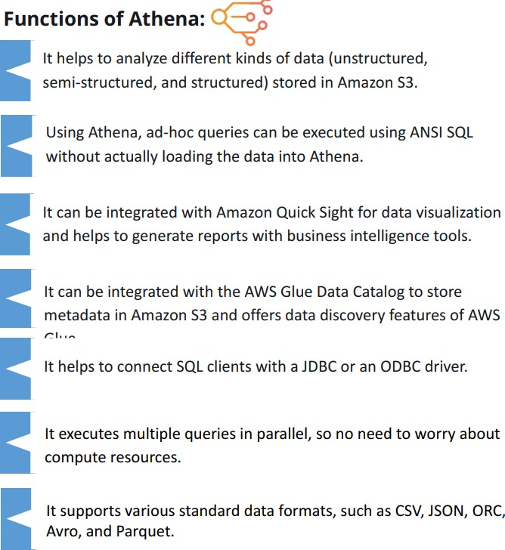

Steps:

1. Type Athena on management console and click athena

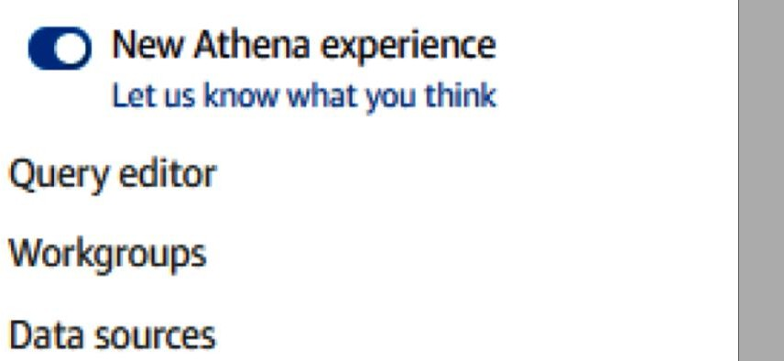

1. On the left you will see three options , click query editor and you will see the following interface.

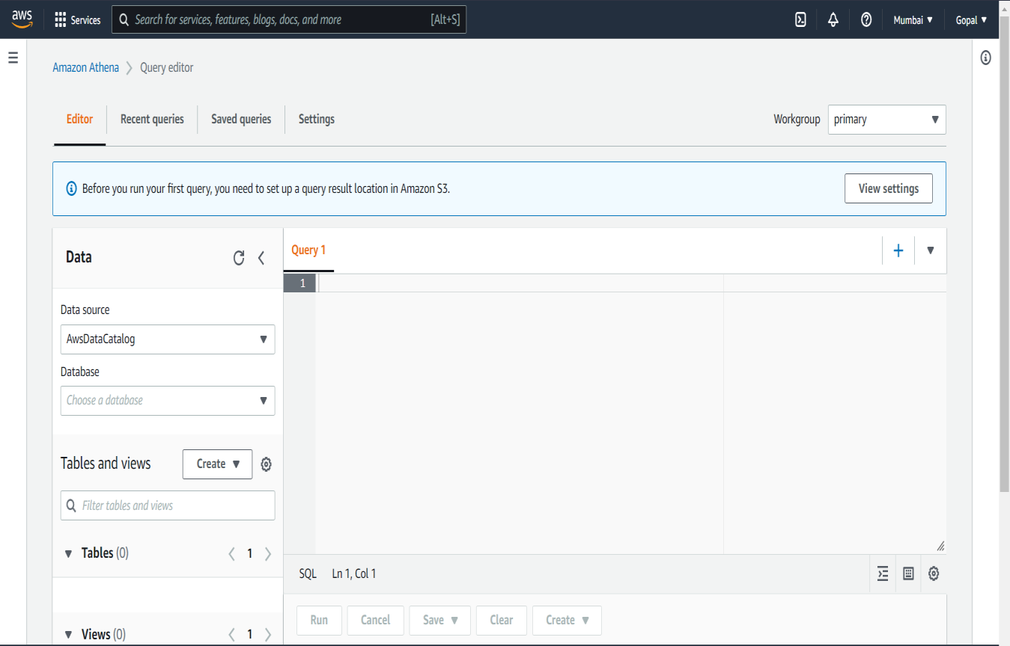

1. 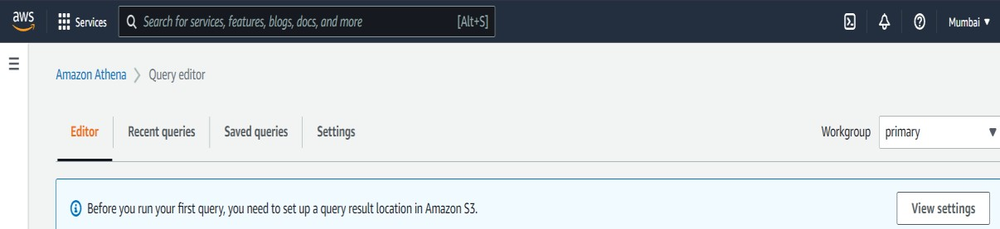From the top right-hand corner, click on the **Settings** link. You will be presented with the following dialog box. You will need to provide the S3 bucket details to store your query results. The format should be **s3://bucket-name**. You can also store your queries in a sub-folder and choose to encrypt your query result.
2. Click on manage

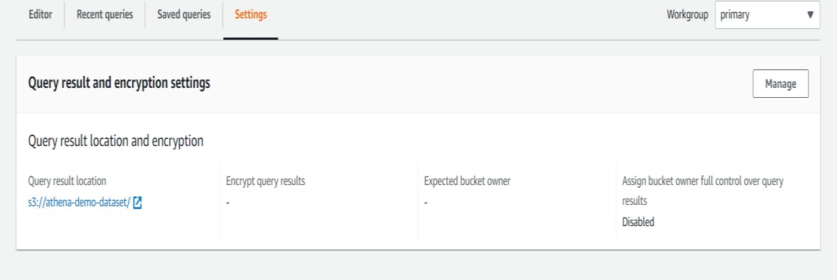

1. Now select the bucket where you want to save

the queries results and click on save.

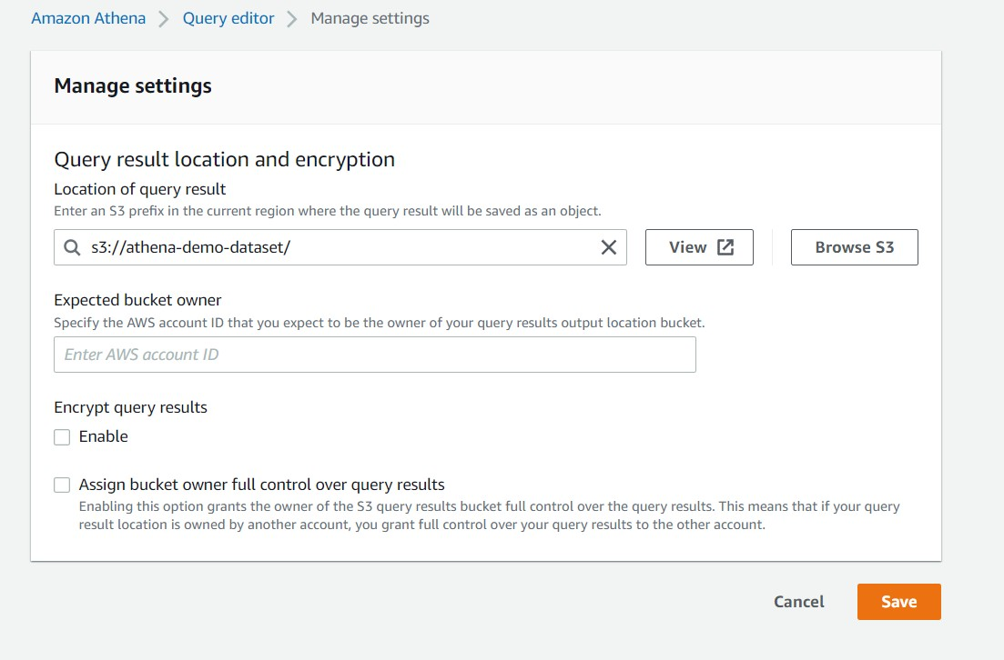

1. Click on create table and choose s3 bucket data and fill the requirements.

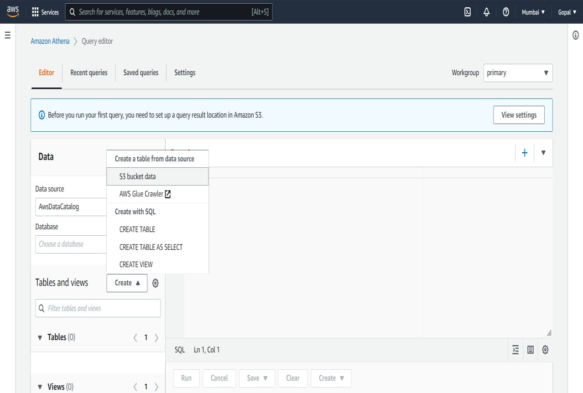

1. Fill the table name and database configuration

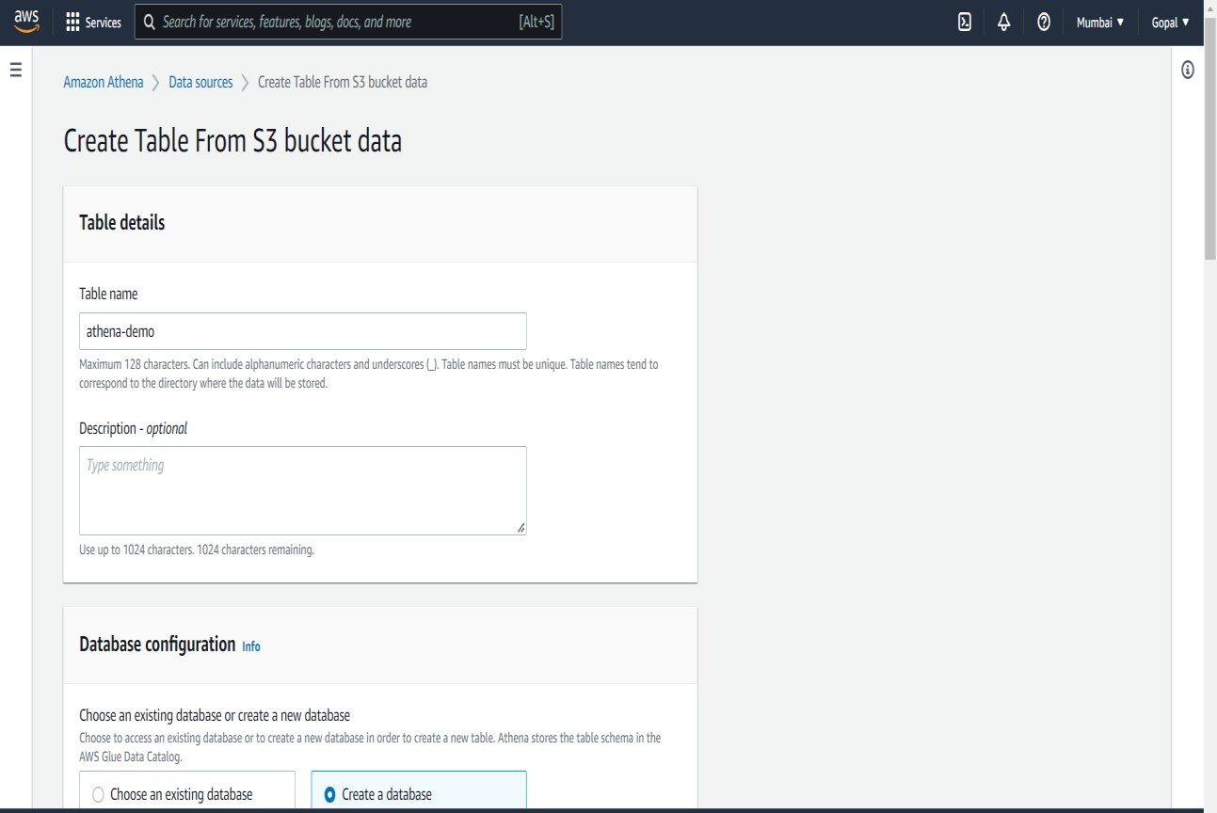

1. Choose the bucket from where you want table to be imported.

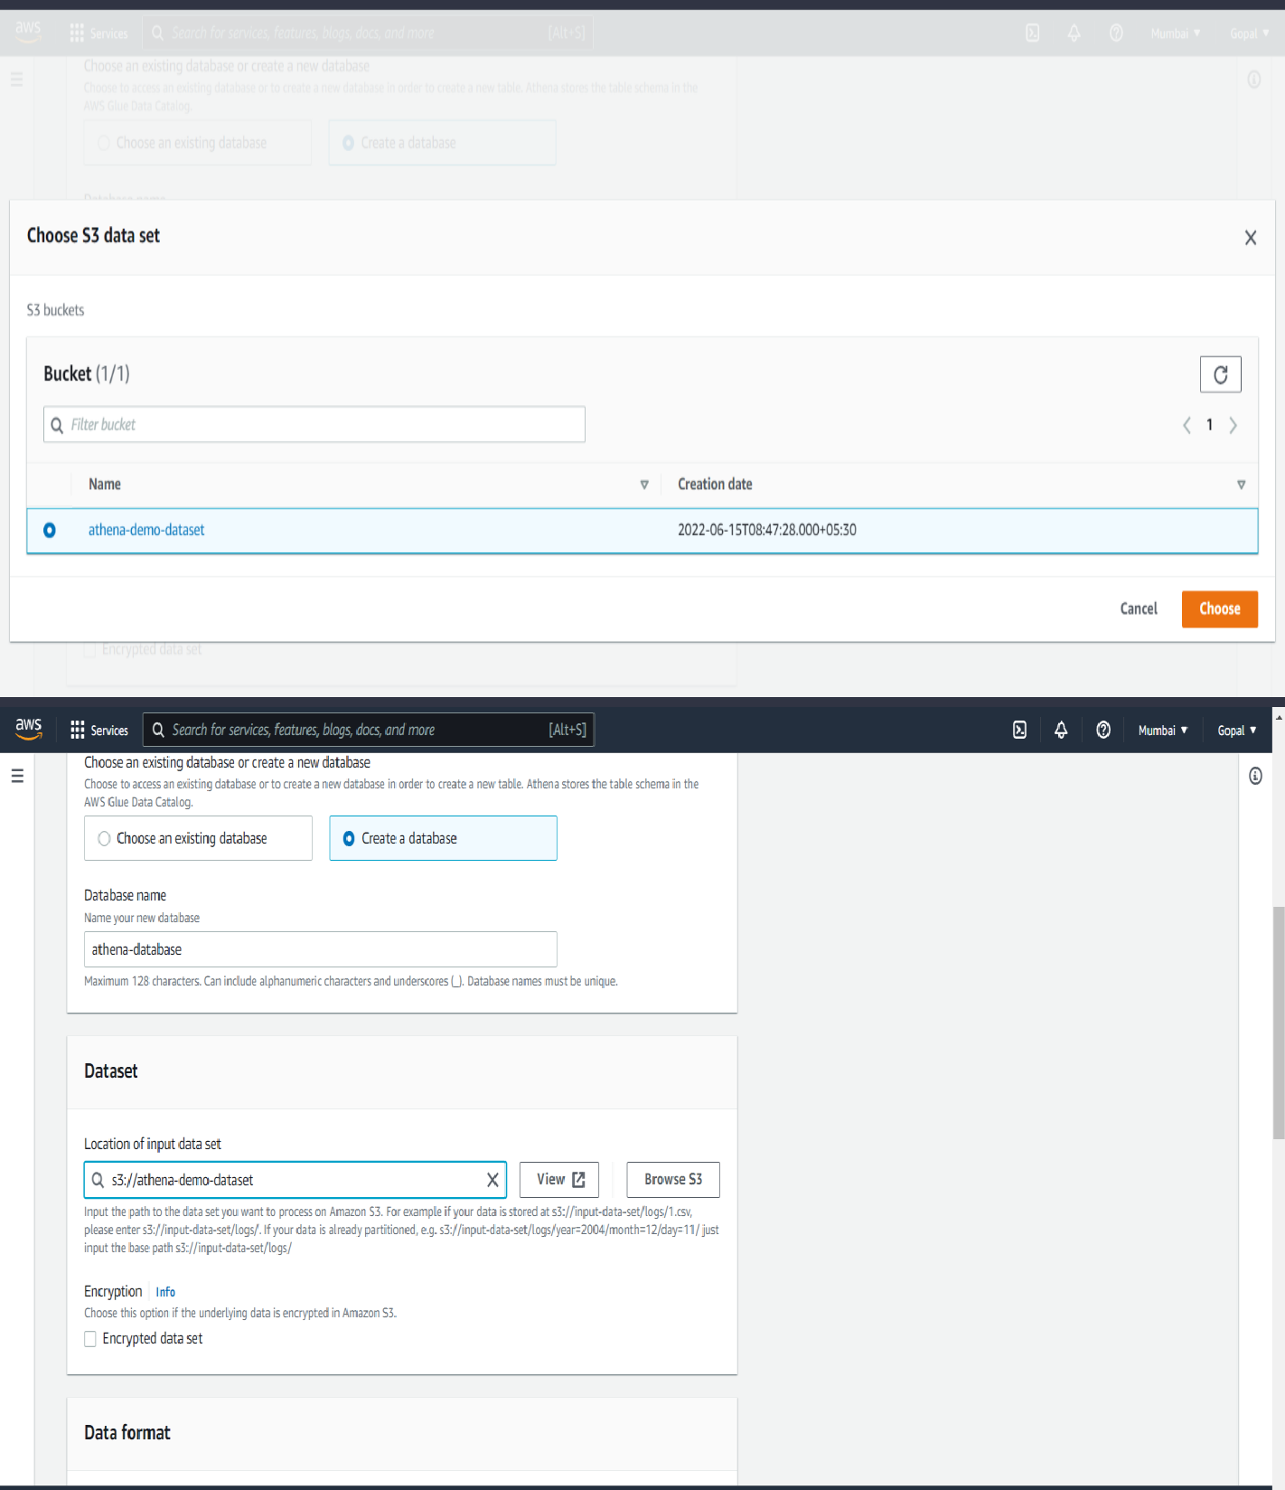

1. Select the data format as CSV and mention the column name of the csv file.

Note : In actual csv file it should not contain the columns name

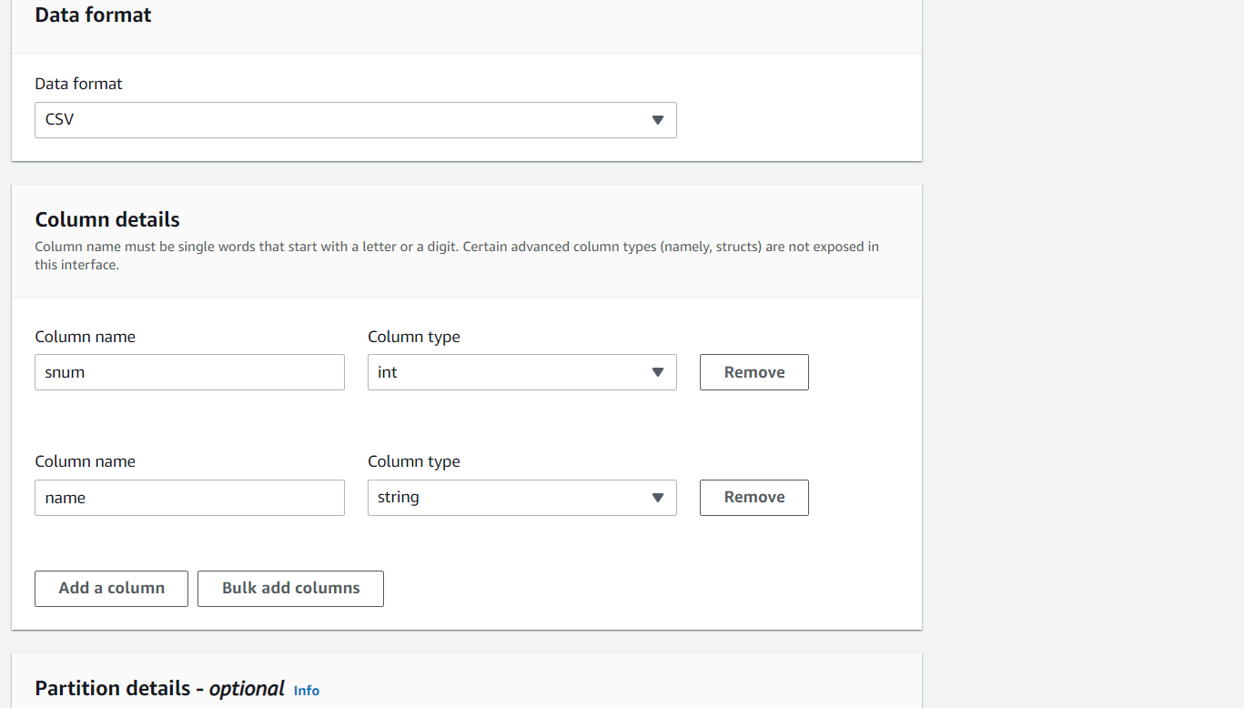

1. Click on create table.

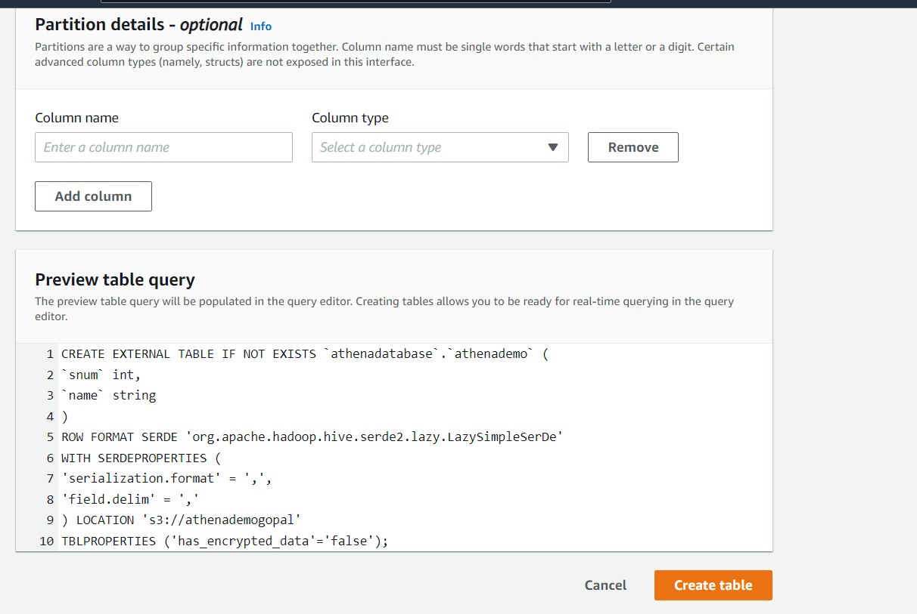

1. Now we can start writing query on the query editor and the output of the query will be saved on s3.

